Table of Contents

Chapter 1. Introduction
- Introduction to the System
- Problem Definition
- Aim
- Objective
- Goal
- Need of System
- Work done by the group

Chapter 2. Hardware and Software requirement
- Introduction
- System environment
- Software requirement
- Hardware requirements

Chapter 3. System Analysis
- Purpose
- Project Scope
- Existing System
- Proposed System
- System Description

Chapter 4.Implementation issues

- PHP
- HTML
- Cascading style sheet(CSS)

Chapter 5. System Design
- Introduction
- Conceptual Design
- Logical Design
- Physical Design
- Data Flow Diagram of “salon Management system”

Chapter 6.User Screens

Chapter 8. Conclusion
- Features of “salon Management system”
- Benefits Accrued from “ salon Management system”
- Limitations of “salon Management system”

Bibliography

CHAPTER # 1

Introduction
Contents:
- Introduction
- Problem Definition
- Aim
- Objective
- Goal
- Need of System

Introduction to the System:

This project is aimed at developing a Web application that depicts online management of beauty parlour.
This software help website admin to see all detail in brief like total number of customer, Total number of appointment, Rejected Appointment, Accepted Appointment, Total Services, Today’s sales, yesterday’s sale, Last seven days sales and total sales.
This software helps user to take appointment with beauty parlor on particular date and time. User views the services which is offer by beauty parlor User sees the details of beauty parlor and can contact with beauty parlor.

Problem Definition:

Managing your beauty parlour management system may seem tricky, but this is part of Customer Service System (application support direct contact with customer)
.

Aim:

“To manage online management of beauty parlour.”

Objective:

This software help website admin to see all detail in brief like total number of customer, Total number of appointment, Rejected Appointment, Accepted Appointment, Total Services, Today’s sales, yesterday’s sale, Last seven days sales and total sales.
This software helps user to take appointment with beauty parlor on particular date and time. User views the services which is offer by beauty parlor User sees the details of beauty parlor and can contact with beauty parlor.

Goal:

The beauty parlours handle the entire advance table booking manually, which is very tedious and mismanaged.

The objective of our project is as follows:

To keep the information of customer.

To keep all detail in brief like total number of customer, Total number of appointment, Rejected Appointment, Accepted Appointment.

To keep the information of Total Services, Today’s sales, yesterday’s sale, Last seven days sales and total sales..

Need of the System:

There is always a need of a system that will perform online appointments in beauty parlours and manage customers and booking records.
This system will reduce the manual operation required to maintain all the records. And also generates the various reports for analysis.

Work done by the group:

1. Dipraj Daripa : Full code of this project, synopsis.

2. Alok Raj : given some ide about the project , write the project report in wordpad.

3. Ajit kumar : Nothing.

CHAPTER # 2
Hardware and Software Requirements

Contents:
- Software requirement
- Hardware requirements

Software Requirements:

- Microsoft Windows 7/8/10 or Linux.
- XAMPP (MySQL, Apache, PHP).
- Notepad++ or any other text editor.
- Chrome or any other browser.

Hardware Requirements:

- Intel Processor 2.0 GHz or above.
- 2 GB RAM or more.
- 160 GB or more Hard Disk Drive or above.

CHAPTER # 3
System Analysis

Contents:

Purpose
- Project Scope
- Existing System
- Proposed System
- System Overview

Purpose:

To manage the online appointment in beauty parlour. It helps to customer to
take appointment online from anywhere.
This project also helps in administrative work such as keep information of customers and appointment bookings.

Project Scope:

The project has a wide scope, as it is not intended to a particular organization. This project is going to develop generic software, which can be applied by any businesses organization. More over it provides facility to its customer. Also the software is going to provide a huge amount of summary data.

Proposed System:

The Online Beauty Parlour Management system is available in the market that can serve customers to take appointment and view our appointment status online.

System Overview:

User (Customer) Modules:

User can see the ----
0. Home Page: Users can take appointments with salon on particular date and time.
0. Services: User views the services which is offer by salon.
0. About Us: User sees the details of salon.
0. Book online: User can booking a slot.
User can see the booking rate for various thing also—
- For facials – under 1000, 2000,3000
- For makeup – under 1000, 2000,3000
- For nails- under 1000,2000,3000
0. Contact Us: User can contact to salon.
0. Special Days: User can booking for special days like weeding, a particular season special, ect Special Days.

#. User can also see beautify facebook, Twtter, and Insta account. Link is given in the home pages

CHAPTER # 4
Implementation issues
4.1 PHP

PHP can be defined as a programming language for Database access from the web's browser. In other words, it is an HTML-embedded scripting language. It focuses on the logic of how a page responds to user input and not how the page looks that i.e. not the primary appearance of the page.
PHP runs on the server side, which means that the web server that sends an HTML file to a user's browser, will carry out the instructions found in the embedded PHP code first, and then send the output of the PHP code along with the HTML code. The result is a webpage with dynamic content.

Brief History on PHP:

PHP is a language for creating website that can be more or less interactive. It was created in 1994 by Rasmus Lerdorf who was a software engineer and who was part of the Apache Team. In the same year, he created a package, added some database support and called it PHP/FI (Form Interpretation).
In 1995, it was called the Personal Home Page Tool then was released as version2 with a name called PHP/FI (a form interpreter responsible for analyzing queries). In mid of 1997, more than 50,000 websites began using PHP and in October, 1998, there was an increase in the number of websites using PHP which was about 100,000.
In 2000, there was a release of PHP 4.0.2. And currently over 1,000,000 sites in the whole world are using PHP.

4.2 HTML

HTML (Hypertext Markup Language) is the set of markup symbols or codes inserted in a file intended for display on a World Wide Web browser page. The markup tells the Web browser how to display a Web page's words and images for the user. Each individual markup code is referred to as an element (but many people also refer to it as a tag). Some elements come in pairs that indicate when some display effect is to begin and when it is to end.

4.3 CASCADING STYLE SHEET (CSS)

Cascading Style Sheets (CSS) are a collection of rules we use to define and modify web pages. CSS are similar to styles in Word. CSS allow Web designers to have much more control over their pages look and layout. For instance, you could create a style that defines the body text to be Verdana, 10 point. Later on, you may easily change the body text to Times New Roman, 12 point by just changing the rule in the CSS. Instead of having to change the font on each page of your website, all you need to do is redefine the style on the style sheet, and it will instantly change on all of the pages that the style sheet has been applied to. With HTML styles, the font change would be applied to each instance of that font and have to be changed in each spot.

CSS can control the placement of text and objects on your pages as well as the look of those objects.

HTML information creates the objects (or gives objects meaning), but styles describe how the objects should appear. The HTML gives your page structure, while the CSS creates the “presentation”. An external CSS is really just a text file with a .css extension. These files can be created with Dreamweaver, a CSS editor, or even Notepad.

The best practice is to design your web page on paper first so you know where you will want to use styles on your page. Then you can create the styles and apply them to your page.

Javascript

JavaScript is a programming languagecommonly used in web development. It was originally developed by Netscape as a means to add dynamic and interactive elements to websites. While JavaScript is influenced byJava, the syntax is more similar to C and is based on ECMAScript, a scripting language developed by Sun Microsystems.
JavaScript is a client-side scripting language, which means the source code is processed by the client's web browser rather than on the web server. This means JavaScript functions can run after a webpage has loaded without COMMUNICATING with the server. For example, a JavaScript function may check a web form before it is submitted to make sure all the required fields have been filled out. The JavaScript code can produce an error message before any information is actually transmitted to the server.
Like server-side scripting languages, such as PHP and ASP, JavaScript code can be inserted anywhere within the HTML of a webpage. However, only the output of server-side code is displayed in the HTML, while JavaScript code remains fully visible in the source of the webpage. It can also be referenced in a separate .JS file, which may also be viewed in a browser.

CHAPTER # 5
System Design

Contents:

- Use case diagram
- Class Diagram
- Sequence Diagram
- Context Diagram

Use Case Diagram:
- Use case diagram consists of use cases and actors and shows the interaction between them. The key points are:
- The main purpose is to show the interaction between the use cases and the actor.
- To represent the system requirement from user’s perspective.
- The use cases are the functions that are to be performed in the module.

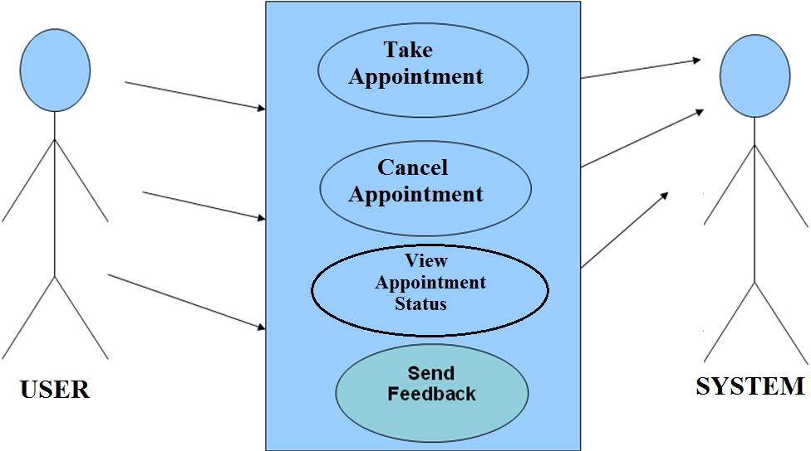

Use Case Diagram between USER and SYSTEM:

Sequence Diagram For User:-

Login
Application
Login
:Request

User

Context Diagram:
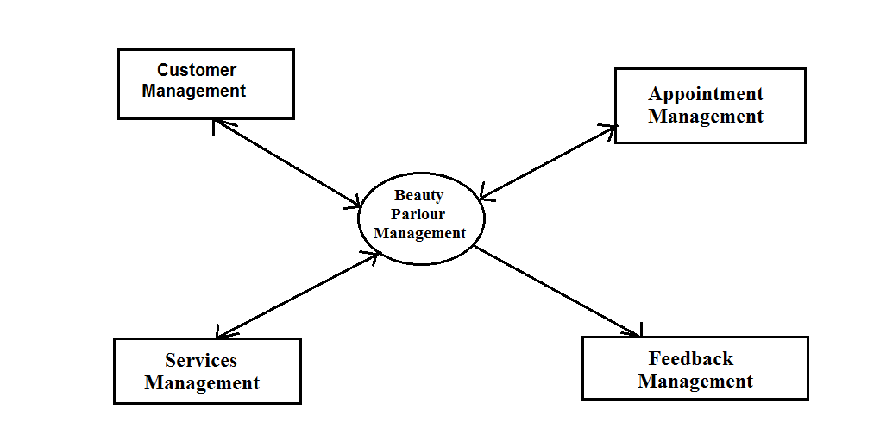

ENTITY RELATIONSHIP(ER) DIAGRAM
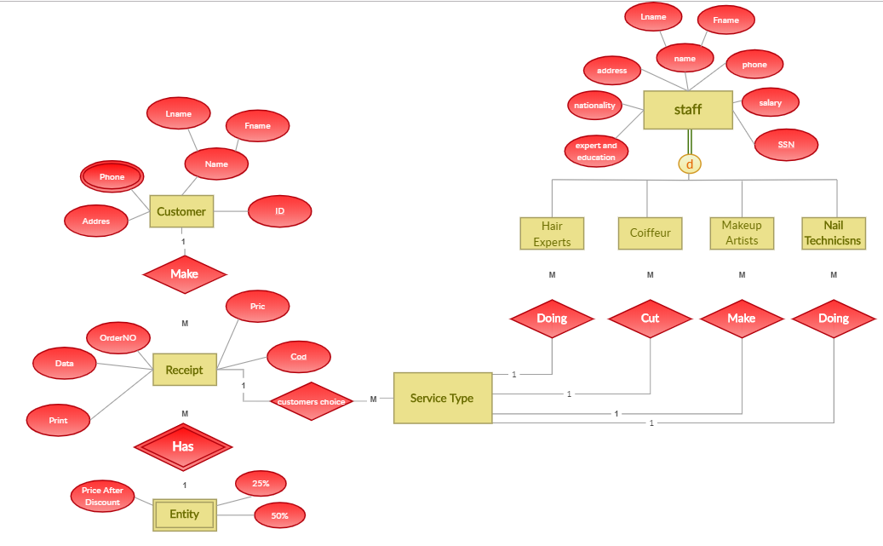

CHAPTER # 6
Output screens
HOME PAGE

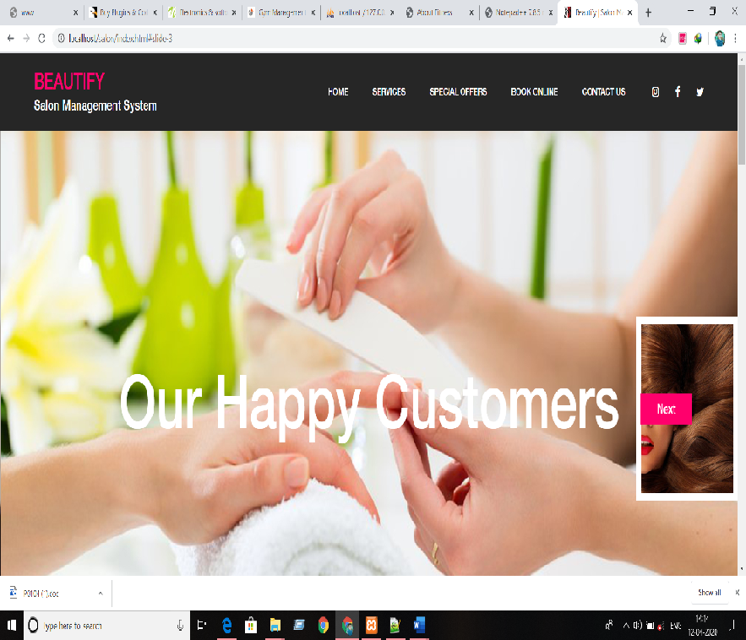

OUR SERVICE PAGE
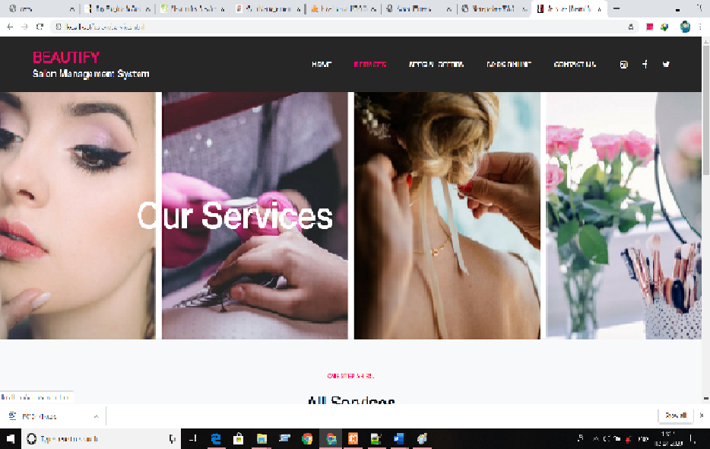

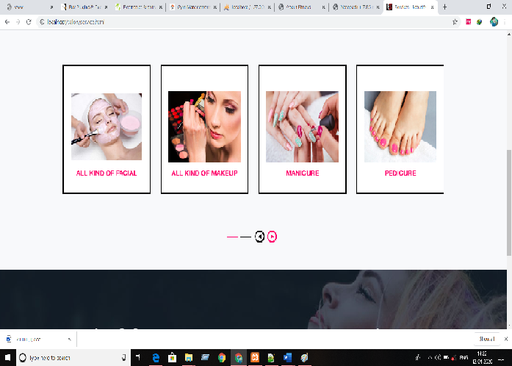

SPECIAL OFFERS

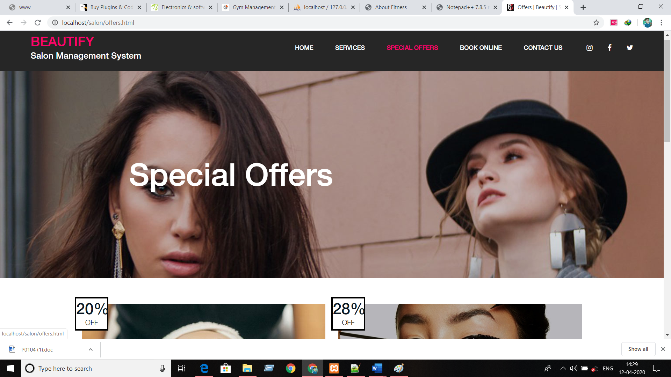

BOOKING ONLINE

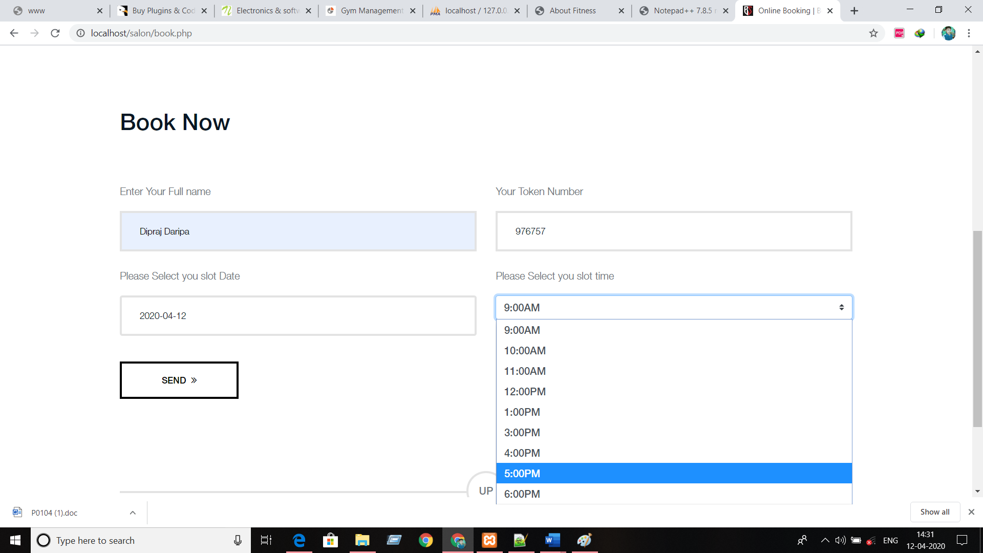

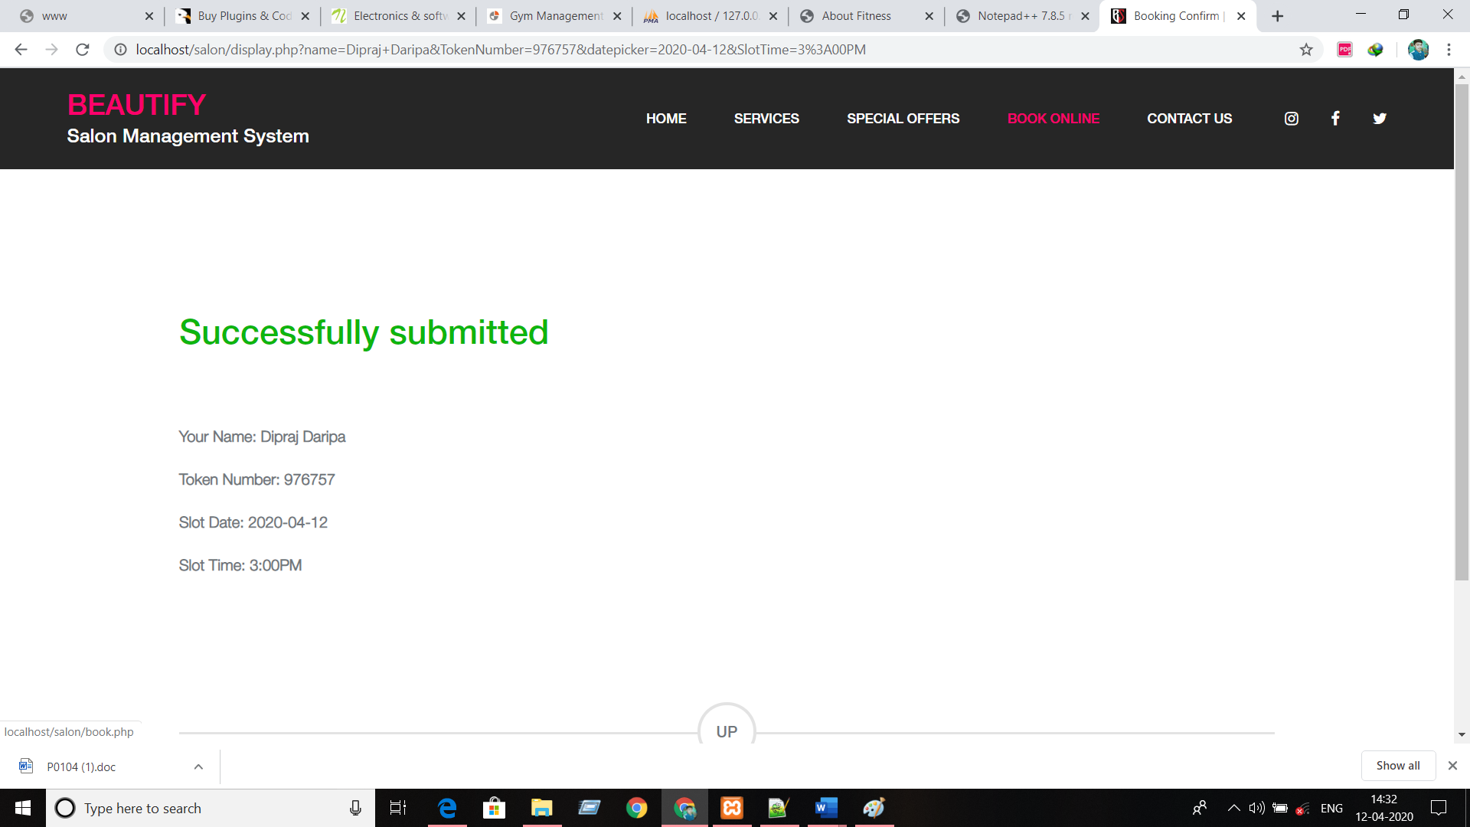

CHAPTER # 8
Advantages & Limitations

Advantages of “Online Beauty Parlour Management System”:
“Online Beauty Parlour Management System” provides various features, which complement the information system and increase the productivity of the system. These features make the system easily usable and convenient. Some of the important features included are listed as follows:
- Intelligent User Forms Design
    - Data access and manipulation through same forms
    - Access to most required information
- Data Security
- Restrictive data access, as per login assigned only.
- Organized and structured storage of facts.
- Strategic Planning made easy.
- No decay of old Records.
- Exact financial position of the Business.

Limitations of “Online Beauty Parlour Management System”:

Besides the above achievements and the successful completion of the project, we still feel the project has some limitations, listed as below:
  - It is not a large scale system.
  - Only limited information provided by this system.
  - Since it is an online project, customers need internet connection.
  - People who are not familiar with computers can’t use this software.

CHAPTER # 8
Future Scope

FUTURE SCOPE
This web application involves almost all the features of the online booking. The future implementation will be online help for the customers and chatting with website administrator.

CONCLUSION

The project entitled “Online Beauty Parlour Management System” is developed using HTML , CSS and Bootstrap as front end and PHP , MYSQL database in back end to computerize the process of online management of customers and appointments of beauty parlour. This project covers only the basic features required.

Bibliography

BIBLIOGRAPHY

- FOR PHP INSTALLATION

- http://www.php.net/
- XAMPP download for php
https://www.apachefriends.org/download.html

- FOR CSS

- http://cssed.sourceforge.net/

- FOR OTHER USEFUL REFERENCES

- http://www.w3schools.com/default.asp
- http://en.wikipedia.org/

- REFERENCE BOOKS
Lee Babin, “Beginning Ajax with PHP”.
Leon Atkinson,“ Core PHP Programming” .
Luke Welling & Laura Thompson, “Beginning Ajax with PHP”.
Roger S.Pressman, “Software Engineering”.

